**PUNE INSTITUTE OF COMPUTER**

**TECHNOLOGY**



**Department of Computer Engineering**

**LP-IV**

**Batch**: - P1

**STQA Mini Project**

**Dynamic website of covid-19 information**

41117– Ritu Chudiwal

**Guided by**: -Prof.D.D.Bhaiyya

**1.PROBLEM STATEMENT:**

Software Testing and Quality Assurance Mini Project Dynamic webside of covid-19 information using HTML, CSS, JAVASCRIPT And PHP, MySQL database used to store user account, comment, and registration form details. Regular Expression testcases for testing purpose.

**2.OBJECTIVE:**

We are going to learn how to Prepare Test Cases inclusive of Test Procedures for identified TestScenarios. Perform selenium testing with regular expression check Prepare Test Reports based on Test Pass/Fail Criteria.

**3.THEORY:**

Test Plan for Website Testing the Test Plan document is derived from the Product Description, Software Requirement Specification, Use Case Documents. The focus of the test is what to test, how to test, when to test, and who will test. Test plan document is used as a communication medium betweentest team and test managers. A standard test plan for Website Testing should define following features;

* Define the scope of testing
* Define objective of testing
* Approach for testing activity
* Schedule for testing
* Bug tracking and reporting

Steps for Download & Install Selenium WebDriver :

1. Install Java on your computer
2. Install Eclipse IDE
3. Download the Selenium Java Client Driver
4. Configure Eclipse IDE with WebDriver

**SELENIUM TESTING** : Selenium is an open source umbrella project for a range of tools and libraries aimed at supporting browser automation. It provides a playback tool for authoring functional tests across most modern web browsers, without the need to learn a test scripting language. Regular expressions are a very useful technique for improving Selenium WebDriver tests. They can be used for

▪ Extracting text from the value of a webelement

▪ Validating if a value matches a specific pattern

▪ Validating if a url matches a pattern

Test Scenarios for the Sign-up page :

1. Verify the messages for each mandatory field.
2. Verify if the user cannot proceed without filling all the mandatory fields.
3. Verify the age of the user when the DOB is selected.
4. Verify if the numbers and special characters are not allowed in the First and Last name.
5. Verify if a user can sign-up successfully with all the mandatory details.
6. Verify if a user can log in with the valid details.
7. Verify if the Password and Confirm Password fields are accepting similar strings onl 8) Verify if the Password field will prompt you for the weak passwords.
8. Verify if duplicate email address will not get assigned.
9. Verify that hints are provided for each field on the form, for the ease of use.

**5. SCREENSHOTS:**

**1.Signup Page:**

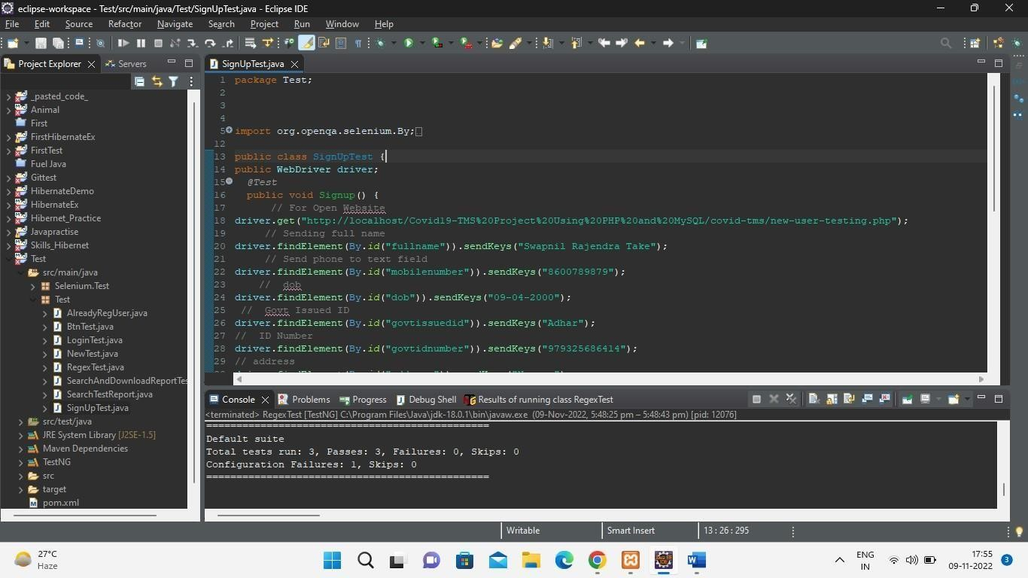

**2.Regex Test:**

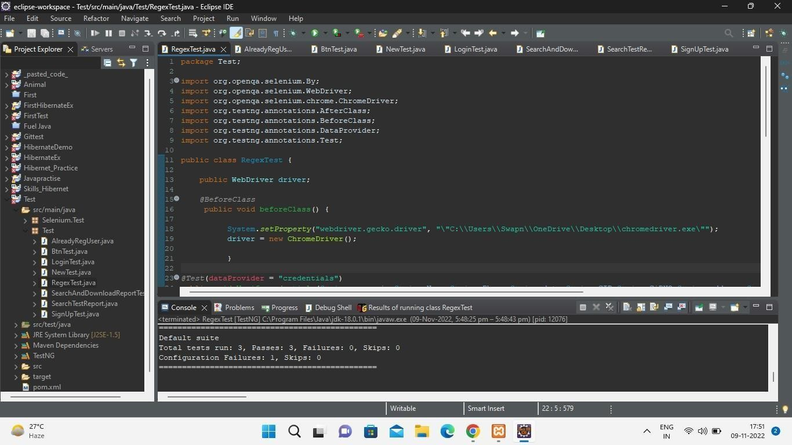

**3. Registred user login :**

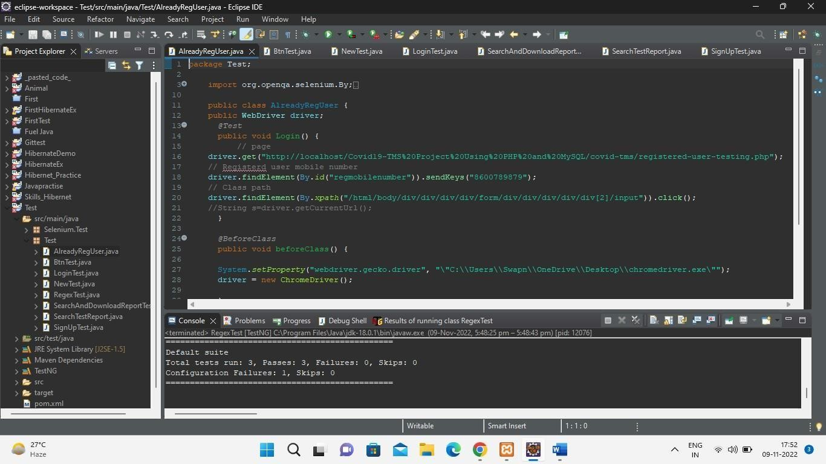

**4.Login:**

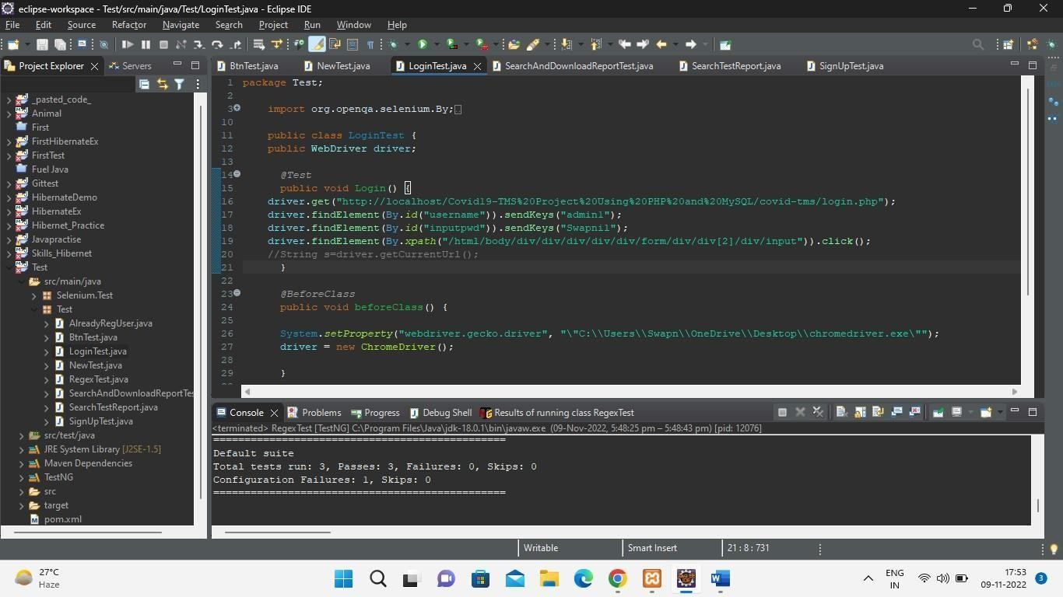

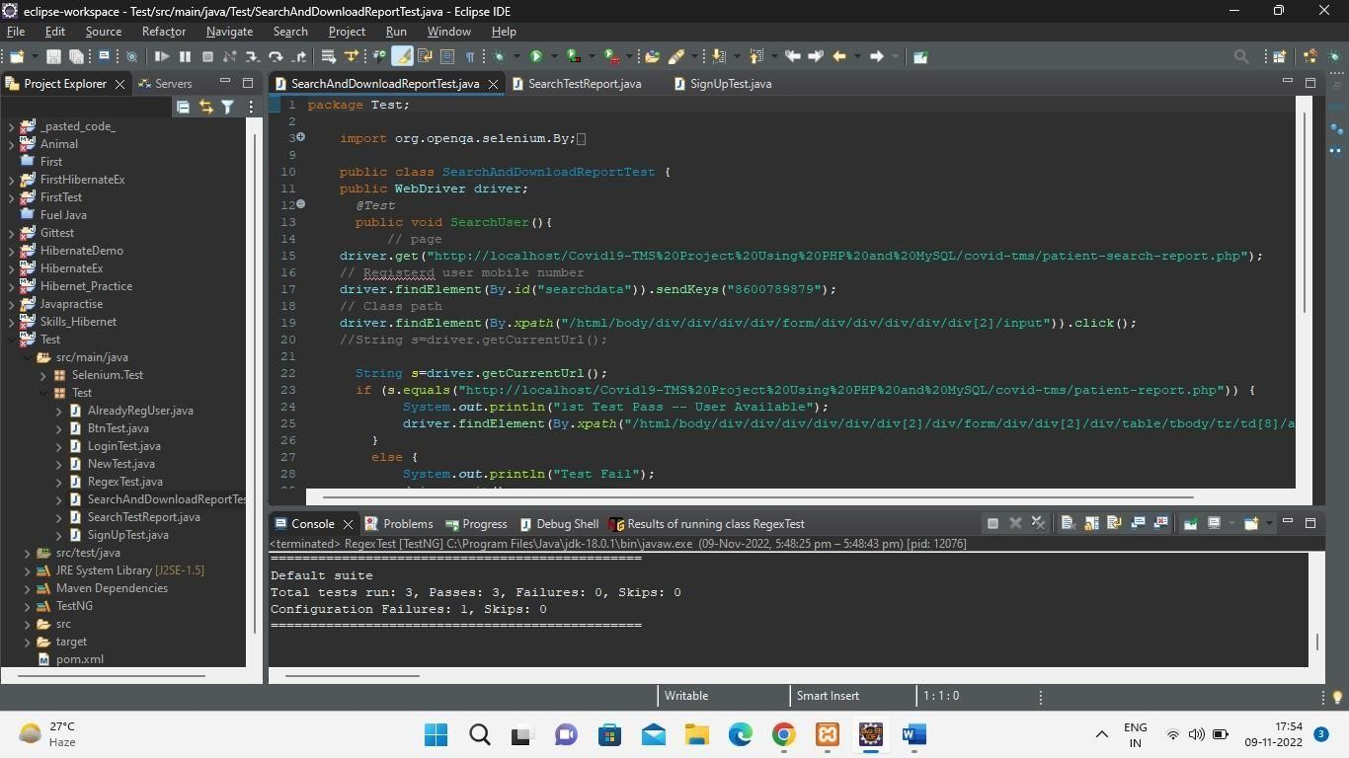

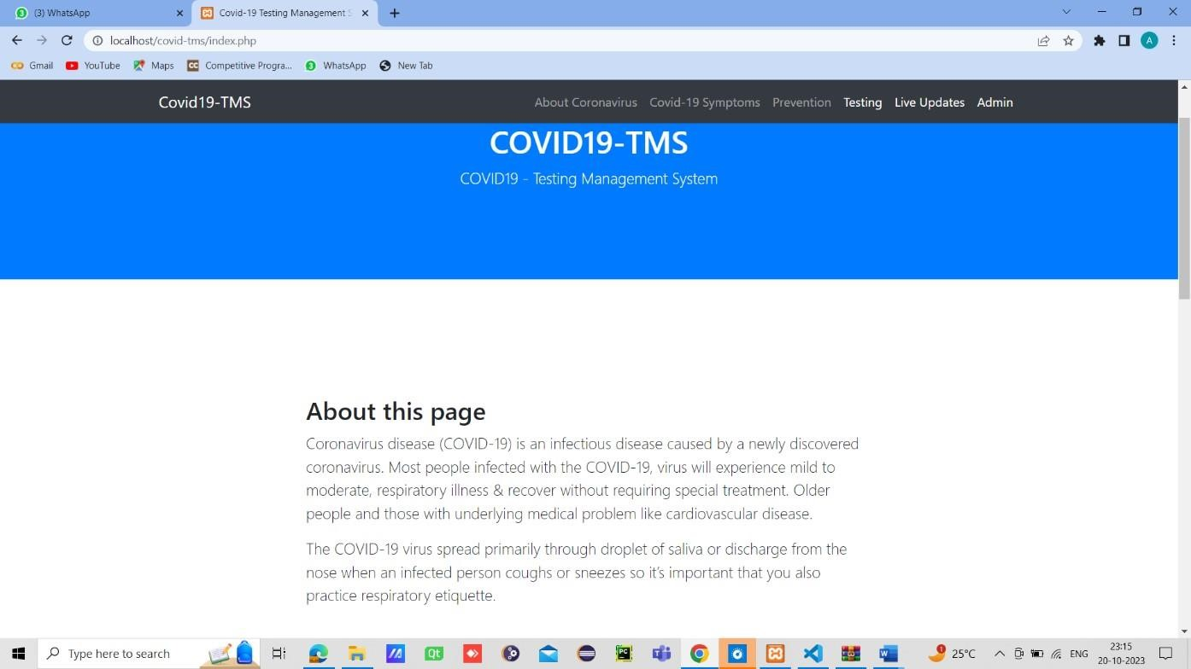

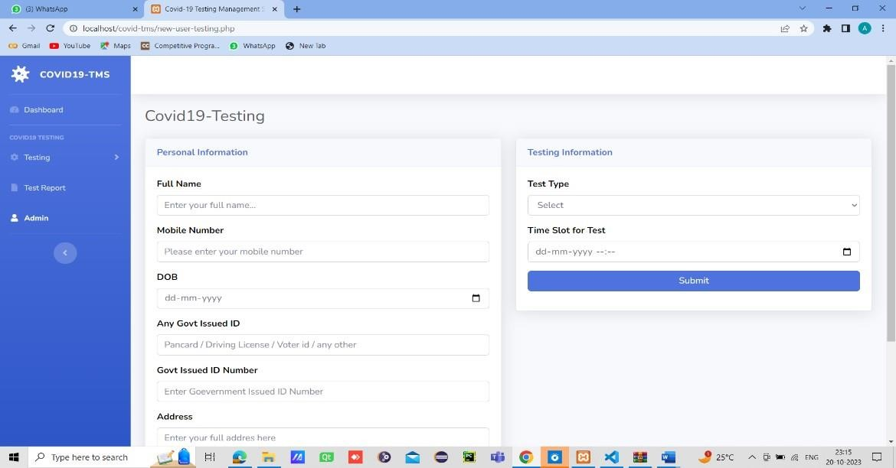

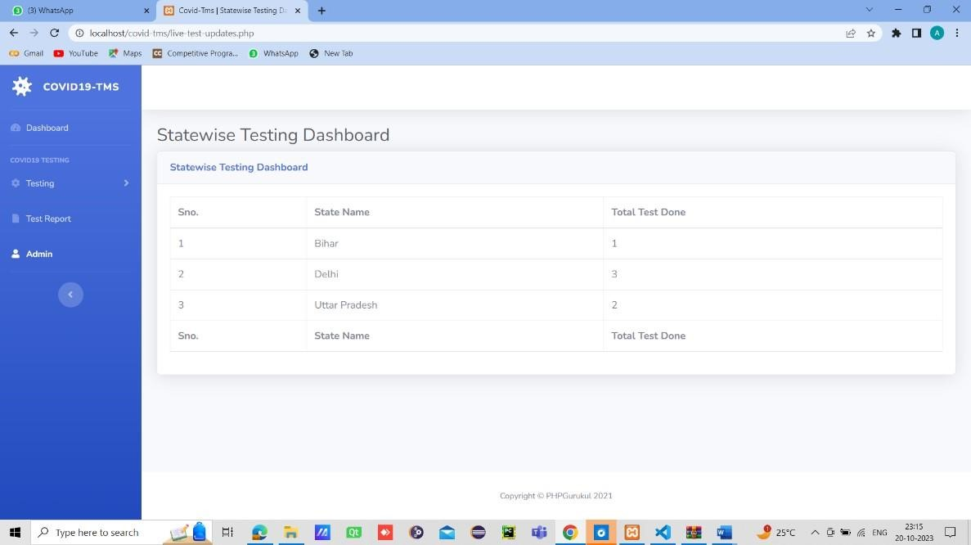

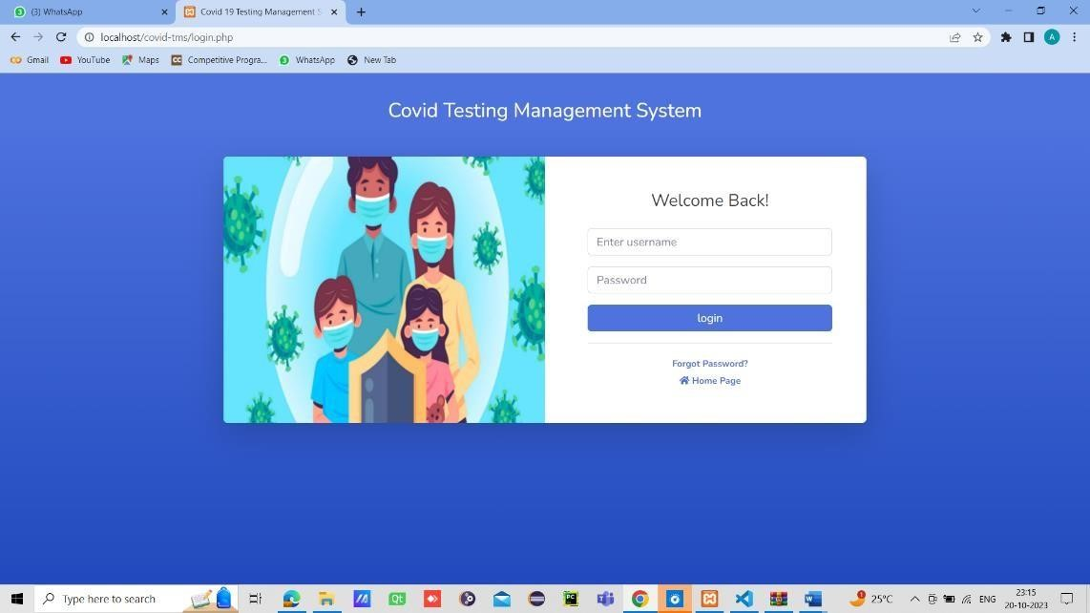

|  |  |  |  |  |  |
| --- | --- | --- | --- | --- | --- |
| **Approach** | **Type of**  **Testing** | **Manual Testing** | | **Automated Testing**    **on Device** | **Tools/APIs/Libraries** |
| **Using**  **Devic e** | **Using**  **Emulat**  **Or** |
| Standard  Testing  (Functional  Testing) | Selenium  Testing | No | Yes | No | 1. Selenium |

**Selenium testing**

|  |  |
| --- | --- |
| **EXECUTION STATUS** | **COMPLETED/CANCELLED**/PENDING |
| **PASSED TESTCASES** | 7 |
| **FAILED TESTCASES** | 2 |
| **PENDING TERSTCASES** | 0 |
| **TEST CASES**  **PLANNED** | 7 |

|  |  |  |  |  |  |  |
| --- | --- | --- | --- | --- | --- | --- |
| **MODULES/ SCENARIOS** | **DESCRIPTION** | **% TCs**  **EXECUTED** | **% TCs**  **PASSED** | **TCs**  **PENDING** | **PRIORITY** | **REMARKS** |
|  |  |
| **INSERT** | Validation units related to insertion | 63 | 37 | 00 | MODERATE | - |
| **VIEW** | Retrieval of records from DB | 100 | 100 | 00 | LOW | - |
| **SEARCH** | Searching records in DB | 100 | 100 | 00 | MODERARTE | - |

**5. TOOLS**

* 1. Selenium jar file/Selenium IDE
  2. Eclipse IDE
  3. Testing extension in eclipse
  4. Covid information site on local host.

**6.CONCLUSION** :

Selenium is a cost-effective and flexible tool developers can use in the automation testing of their web applications. The most intriguing feature of this software is the ability to test applications across various web browsers. This ensures that websites do not crash or breakdown in certain browsers. The above are examples of using regular expression in web tests. Regular expressions will be much more useful in API testing, where text-parsing is essential.